Turbine Box Hardware Specification
PB 540

Table of Contents
1.0 INTRODUCTION 3
1.1 Purpose 3
1.2 Scope 3
1.3 REVISION HISTORY 3
2.0 THEORY OF OPERATION 3
3.0 DESIGN REQUIREMENTS 3
3.1 Motor 3
3.2 Performance 3
3.3 Material 4
3.4 Turbine board mounting 4
3.5 Gas Sources 4
3.6 Environmental operational conditions 5
3.7 Environmental storage conditions 5
3.8 Positioning requirements 5
3.9 Dimensions 5
3.10 Air inlet interface 5
3.11 Air outlet interfaces 5
3.12 Weight 5
3.13 Lead free 5
3.14 Labeling / Traceability 5
3.15 Temperature sensor 5
3.16 Temperature sensor connector 5
3.17 Motor control wires 6
3.18 Motor control connector 6
3.19 Temperature sensor wires 7
3.20 Electrical insulation 7
3.21 Wiring Position 7
3.22 Packaging 7

INTRODUCTION

Purpose
This document provides the specification for the turbine box for the PB640, PB560, PB540 and PB520.

Scope
This specification describes the functional requirements for the turbine box for the PB640, PB560, PB540 and PB520.

REVISION HISTORY
Revision | Date | Author | Change Description
A | 02 Jun 08 | J.C. Cabrera | Initial Release of Specification.
B | 03-Jun-2008 | G. Sanchez | Clarified performance requirements, made minor formatting changes, and corrected spelling.
C | See Agile | See Agile | UPDATE PER ECO-R172706
D | See Agile | See Agile | Add one more hole on the turbine housing to mount the new collar (adhesive less)
E | See Agile | M. Feeney | Update wire colour table in section 3.18.  Correct test RPM reference from 78000 rpm to 72000 rpm  Clarify Label detail in Section 3.14.

THEORY OF OPERATION
This blower box shall consist of an airflow generator able to deliver a range of flow and pressure sufficient to provide ventilation performance of the PB 640, PB560, PB540 and PB520 devices.
The stream generator is a micro low inertia turbine driven by a brushless DC electric motor.
The blower box materials including plastic and metal parts shall be designed to reduce sound level.
The blower shall include a Thermistor NTC 10K Ω sensor type mounted on the motor to allow temp monitoring. Hall Effect sensors shall be available to monitor the blower speed.

DESIGN REQUIREMENTS

Motor
HWTUB1 The motor shall be a brushless DC motor with built-in Open Drain Hall Effect sensor.
HWTUB2 The motor shall operate up to a 24 VDC ±10% supply voltage on each phase.
HWTUB3 The motor shall be able to run with 3A max current.
HWTUB32 The motor sensors shall operate with a 6.2 VDC ±10% supply voltage.

Performance
HWTUB4 The blower shall deliver 100 lpm ±1% into a pressure of 22 hPa ±1% when a current source of 0.90A (+0.2A; -0.15A) is applied.
HWTUB5 The pressure shall be greater than 70mbar with the output of the blower blocked.
HWTUB6 The current shall be 1.15 A +0.5A / - 0.2A with the output of the blower blocked.
HWTUB7 The blower shall deliver a minimum of 250 lpm into a pressure of 24 hPa ± 1% when a current source of 2.4A ± 0.4 A is applied
The blower shall be able to run at 72000 rpm ±1500 for one (1) second. This ensures proper adhesion between the motor and impeller.

Material
HWTUB8 The main shall be made in aluminum and inlet plate shall be made from stainless steel.
HWTUB9 The front part of the enclosure shall be blue molded ABS.

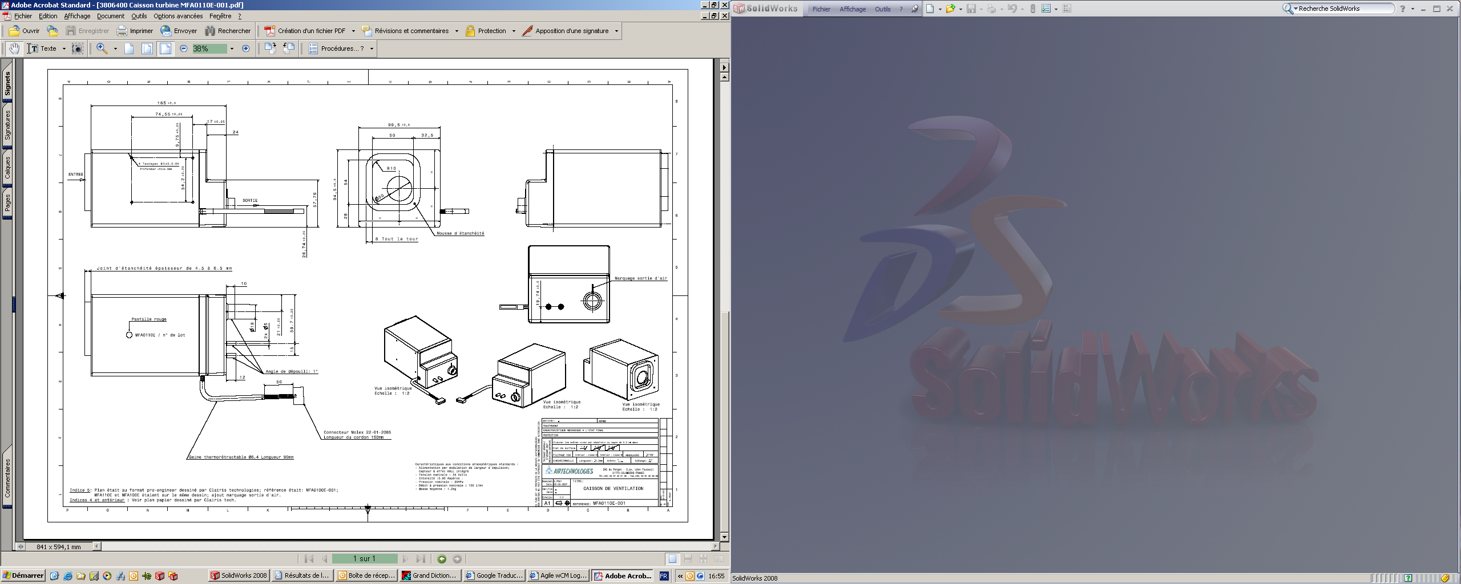
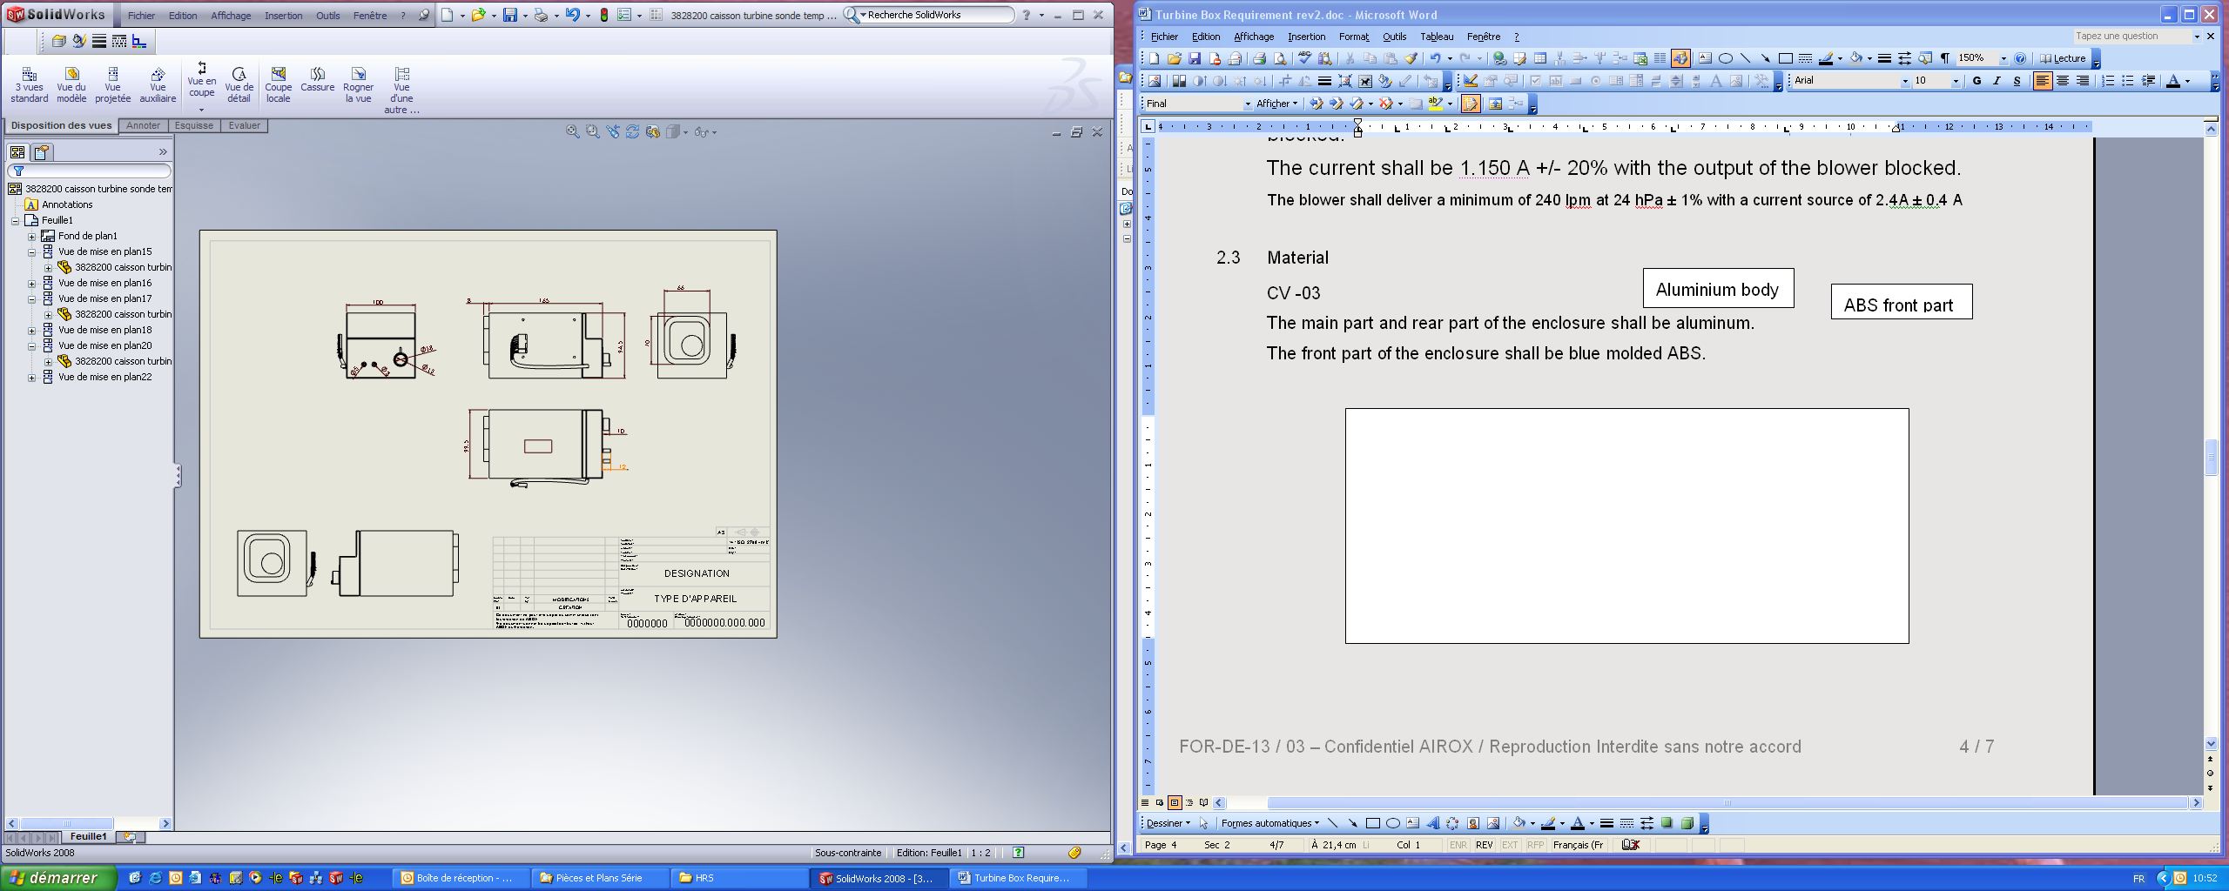
ABS front part
Aluminium body
Inlet Wall
Top Side
Right Side
Inlet Interface foam

Turbine board mounting
HWTUB10 The turbine enclosure shall include 4 - M3x0.5 6H tapped holes on the left side of 3 mm depth for the turbine board to be mounted and a 5th M3x0.5 6H tapped hole for the p-clip collar mounting.

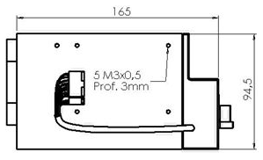

Gas Sources
HWTUB11 The turbine enclosure shall contain an air inlet.
HWTUB12 The turbine enclosure shall contain an oxygen inlet port and an exhalation valve pressure source port at the outlet of the enclosure.
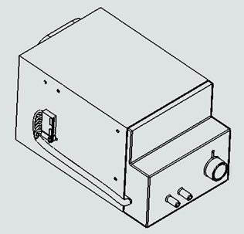
O2 admission port
Exhalation valve pressure source port

Environmental operational conditions
HWTUB13 The blower shall meet its performance requirements when the ventilator is operated at temperatures from 5°C to 40°C, humidity from 10 to 95% RH and barometric pressure from 600 to 1100hPa.

Environmental storage conditions
HWTUB14 The blower shall allow storage conditions from -40°C to + 70°C, from 5 to 95% RH and from 600hPa to 1100hPa barometric pressure.

Positioning requirements
HWTUB15 The blower shall meet its performance requirements when used in any orientation.

Dimensions
HWTUB16 The blower box shall have the following external dimensions (excluding the ports):
Length: 165mm ± 0.5mm
Width: 99.5mm ± 0.5mm
Height: 94.5mm ± 0.5mm.

Air inlet interface
HWTUB17 The inlet interface shall consist of sealed foam glued on the box to ensure the airtightness between the blower box and the housing.

Air outlet interfaces
HWTUB18 The blower box shall provide a main outlet with 18mm ± 0.2mm outside diameter and a draft of 1deg to deliver the flow.
HWTUB19 The blower box shall provide an Oxygen inlet port and an outlet exhalation valve pressure source port with 5mm ± 0.2mm outside diameter and a draft of 1deg.

Weight
HWTUB20 The blower assembly shall weigh 1.2kg ± 0.1kg.

Lead free
HWTUB21 The blower shall be compliant with EN 2002/95/CE guidelines.

Labeling / Traceability
HWTUB23 The blower box shall be labeled with the manufacturer name, manufacturer part number, agile part number and revision, and lot number and/or serial number (with date code).

Temperature sensor
HWTUB24 The blower motor shall integrate a thermistor NTC 10 KΩ ±1% (at 25°C).

Temperature sensor connector
The Temperature sensor connector shall be wired as follows:
Pin Number | Signal Name | Wire Color
1 | Temp - | Red or White
2 | Temp + | Red or White

Motor control wires
HWTUB25 The electrical interface of the blower shall consists of 8 wires of 165mm +5mm/-10mm length / AWG 24 including the connector (Molex 22-01-2085, 8 contacts 08-50-0032). This includes the interfaces for motor control and Hall Effect sensor.

Motor control connector
The motor control connector shall be wired as follows:
Pin Number | Signal Name | Wire Color
1 | Phase 1 | Brown
2 | Phase 2 | Red
3 | Phase 3 | Orange
4 | Sensor Supply | Yellow
5 | GND | Green
6 | PH1 Sensor | Blue
7 | PH2 Sensor | Black
8 | PH3 Sensor | Grey

Timing relationships between the motor phases and the hall sensors:
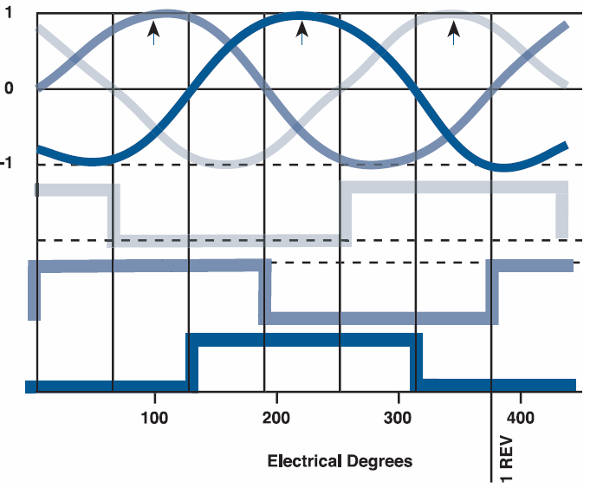
PH1 Sensor
PH2 Sensor
PH3 Sensor
Phase
1 → 2
Phase
2 → 3
Phase
3 → 1

Fig 1: Timing Relationships

Hall Effect position:
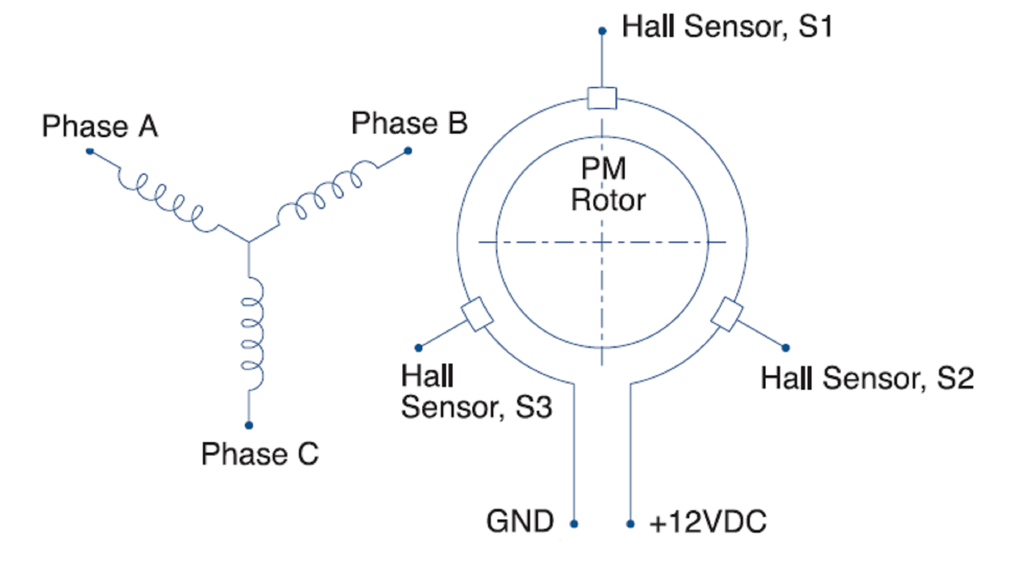
Fig 2: Hall Effect position

Temperature sensor wires
HWTUB26 The temperature sensor wires shall be 165mm +5mm/-10mm length / AWG 30 including connector (Molex 22-01-2025, 2 contacts 08-50-0032)

Electrical insulation
HWTUB27 The wires shall be protected by additional electrical insulation (heat shrink) with a Length of 90mm ± 5mm.

Wiring Position
HWTUB31 The blower box shall be designed with the electrical wires coming from the left side of the box.

Packaging
HWTUB28 The blower box shall be shipped in an individual sealed bag.
HWTUB29 Packaging shall be tested to the international standard ISTA2A.
HWTUB30 Packaging shall be designed to minimize the level of waste and waste disposal as per the European Directive on handling waste packaging.
Certificate Of Compliance is required.

